PNC Algorithm

[1- Sokoban (1)](https://pnc-blocky.netlify.app/exercices/2019/e-jf/pnc-variable-5-sokoban/index.html)

1. Version1

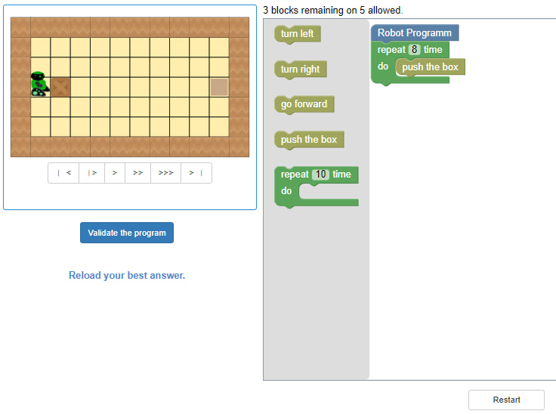

1. Version2

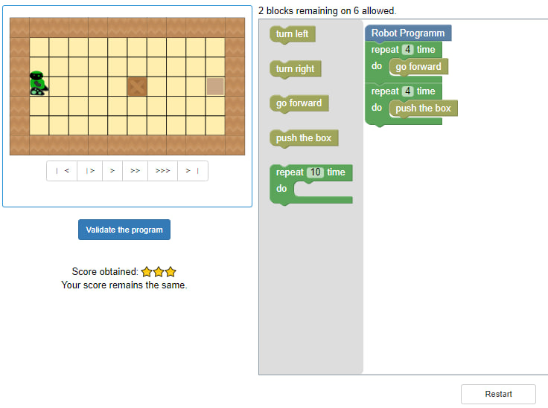

1. Version3

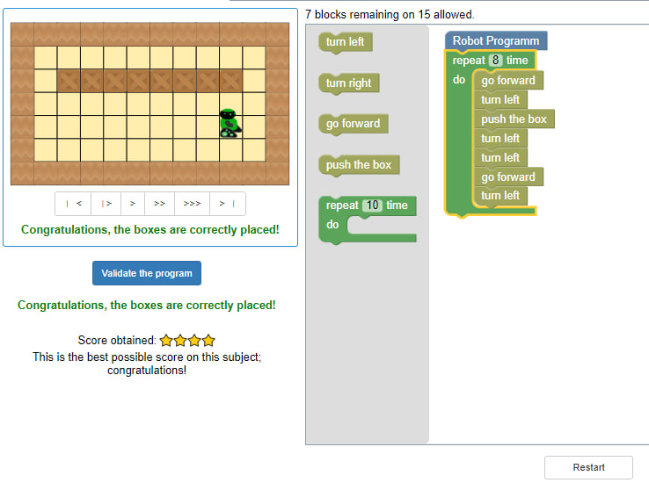

[2-How to use a variable](https://pnc-blocky.netlify.app/exercices/2019/e-jf/pnc-variable-1-start/index.html)

[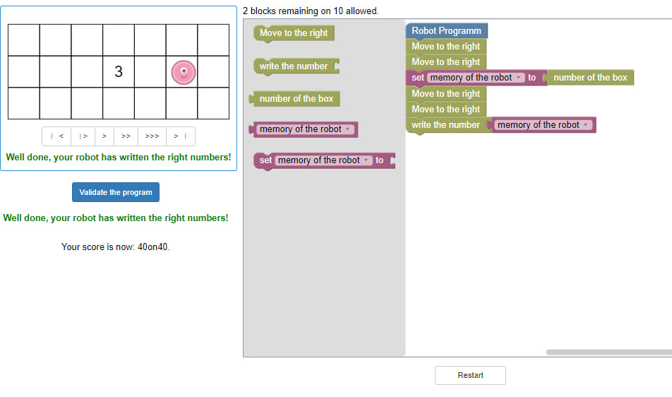](https://pnc-blocky.netlify.app/exercices/2019/e-jf/pnc-variable-1-start/index.html)

[3-Paint using the number (1)](https://pnc-blocky.netlify.app/exercices/2019/e-jf/pnc-variable-2-paint-number/index.html)

1. [Version1](https://pnc-blocky.netlify.app/exercices/2019/e-jf/pnc-variable-2-paint-number/index.html)

[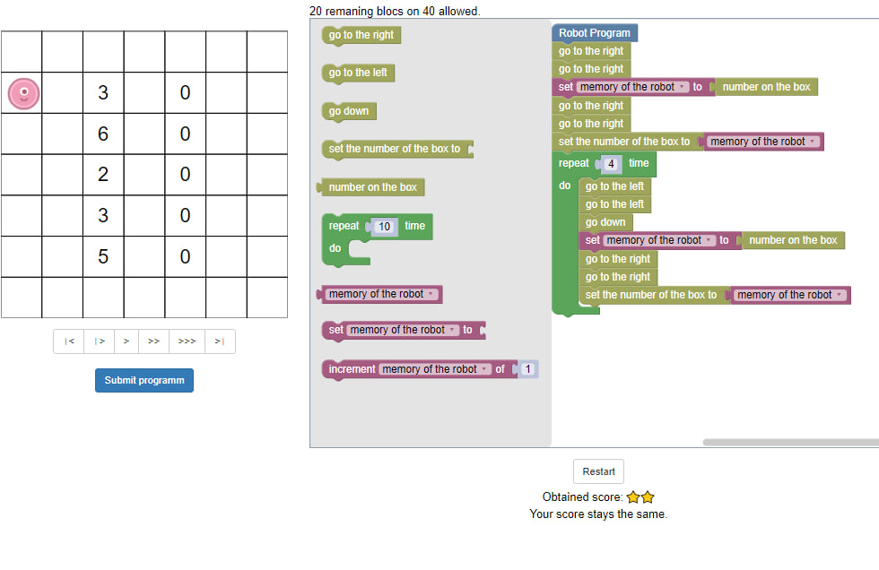](https://pnc-blocky.netlify.app/exercices/2019/e-jf/pnc-variable-2-paint-number/index.html)

1. [Version2](https://pnc-blocky.netlify.app/exercices/2019/e-jf/pnc-variable-2-paint-number/index.html)

[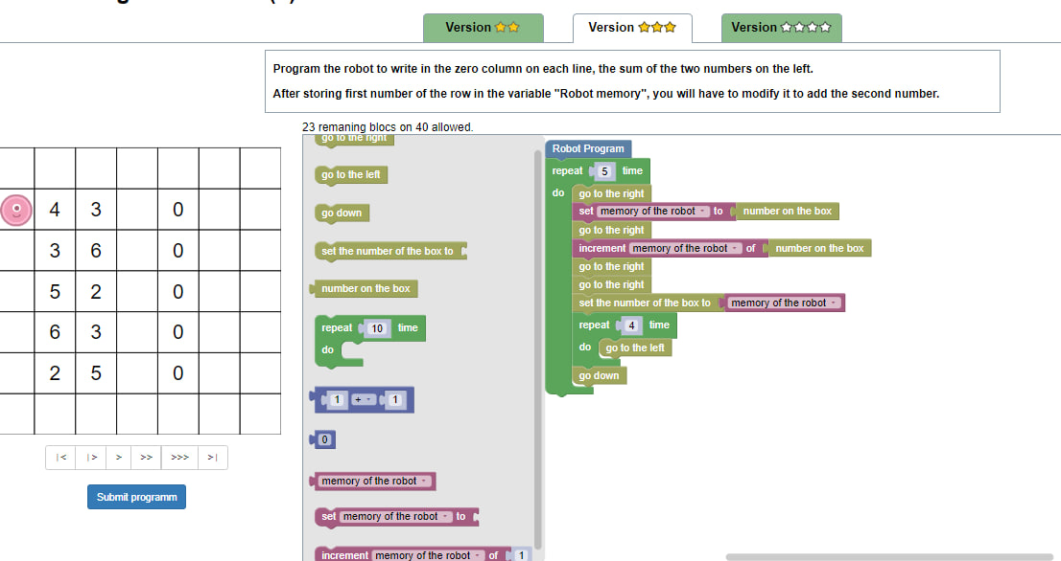](https://pnc-blocky.netlify.app/exercices/2019/e-jf/pnc-variable-2-paint-number/index.html)

1. [Version3](https://pnc-blocky.netlify.app/exercices/2019/e-jf/pnc-variable-2-paint-number/index.html)

[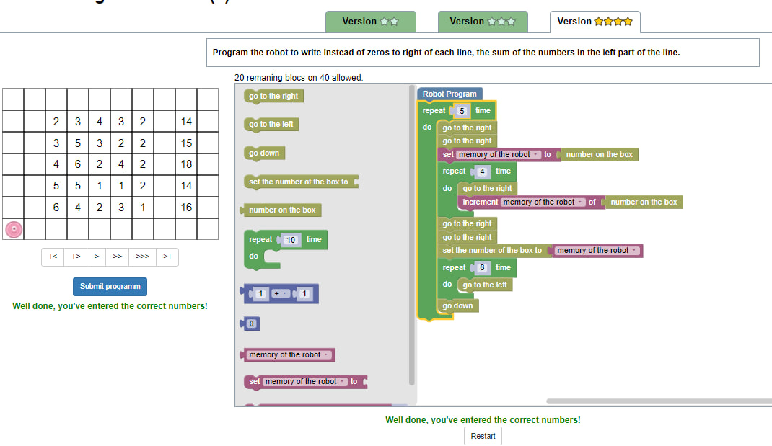](https://pnc-blocky.netlify.app/exercices/2019/e-jf/pnc-variable-2-paint-number/index.html)

[4-Paint using the number (2)](https://pnc-blocky.netlify.app/exercices/2019/e-jf/pnc-variable-4-paint-number/index.html)

1. [Version1](https://pnc-blocky.netlify.app/exercices/2019/e-jf/pnc-variable-4-paint-number/index.html)

[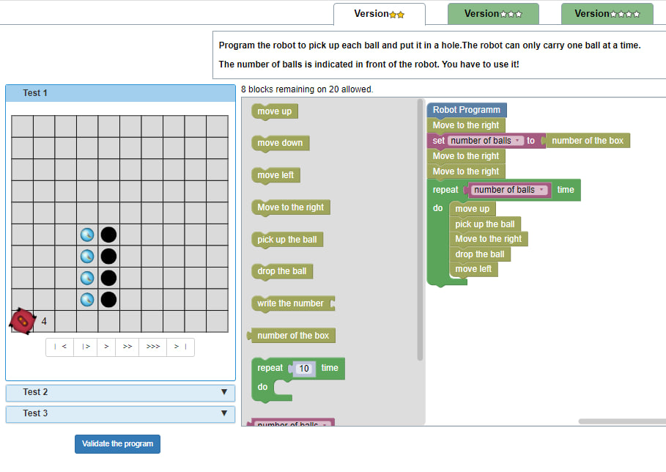](https://pnc-blocky.netlify.app/exercices/2019/e-jf/pnc-variable-4-paint-number/index.html)

1. [Version2](https://pnc-blocky.netlify.app/exercices/2019/e-jf/pnc-variable-4-paint-number/index.html)

[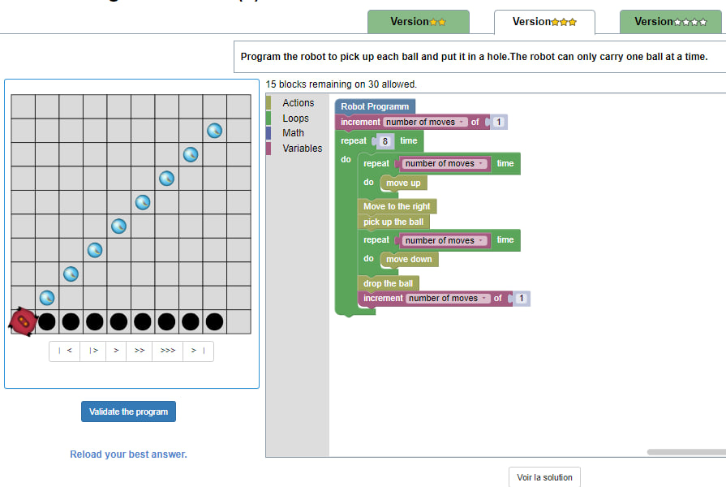](https://pnc-blocky.netlify.app/exercices/2019/e-jf/pnc-variable-4-paint-number/index.html)

1. [Version3](https://pnc-blocky.netlify.app/exercices/2019/e-jf/pnc-variable-4-paint-number/index.html)

[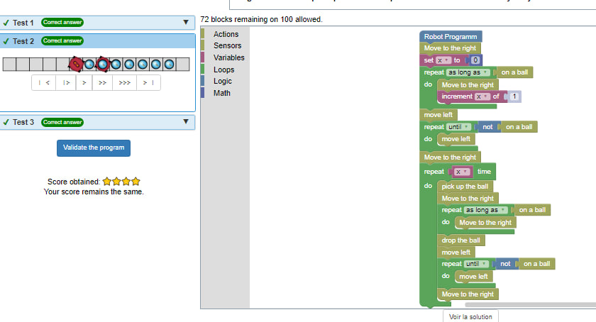](https://pnc-blocky.netlify.app/exercices/2019/e-jf/pnc-variable-4-paint-number/index.html)

[5-Paint using the number (3)](https://pnc-blocky.netlify.app/exercices/2019/e-jf/pnc-variable-3-paint-number/index.html)

1. [Version1](https://pnc-blocky.netlify.app/exercices/2019/e-jf/pnc-variable-3-paint-number/index.html)

[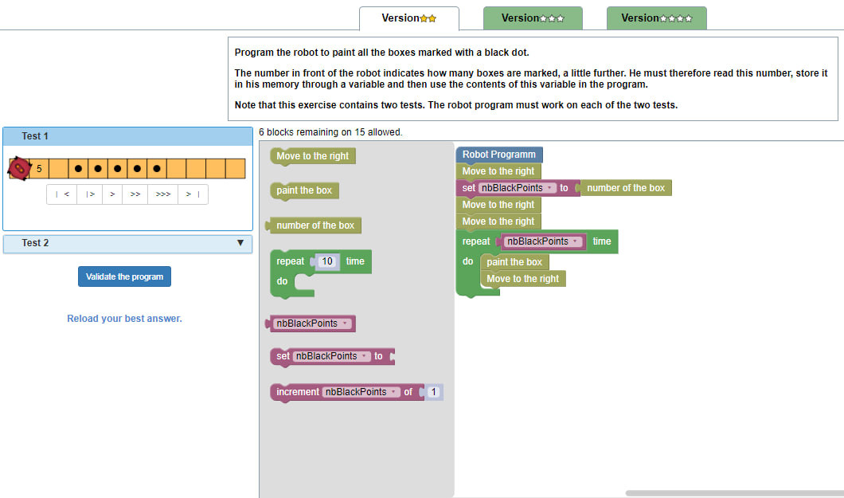](https://pnc-blocky.netlify.app/exercices/2019/e-jf/pnc-variable-3-paint-number/index.html)

1. [Version2](https://pnc-blocky.netlify.app/exercices/2019/e-jf/pnc-variable-3-paint-number/index.html)

[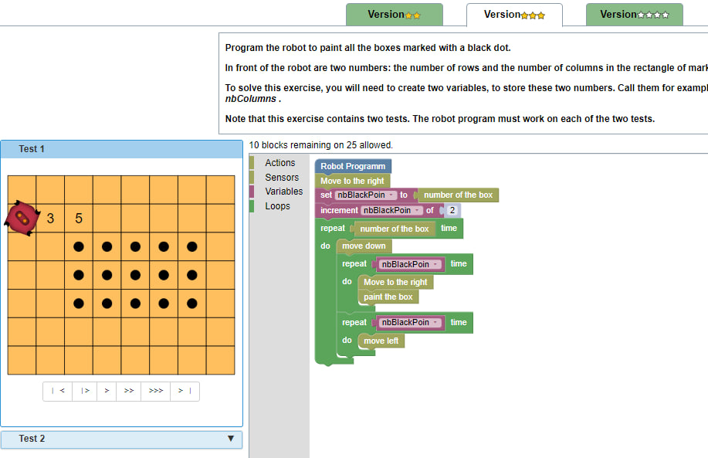](https://pnc-blocky.netlify.app/exercices/2019/e-jf/pnc-variable-3-paint-number/index.html)

1. [Version3](https://pnc-blocky.netlify.app/exercices/2019/e-jf/pnc-variable-3-paint-number/index.html)

[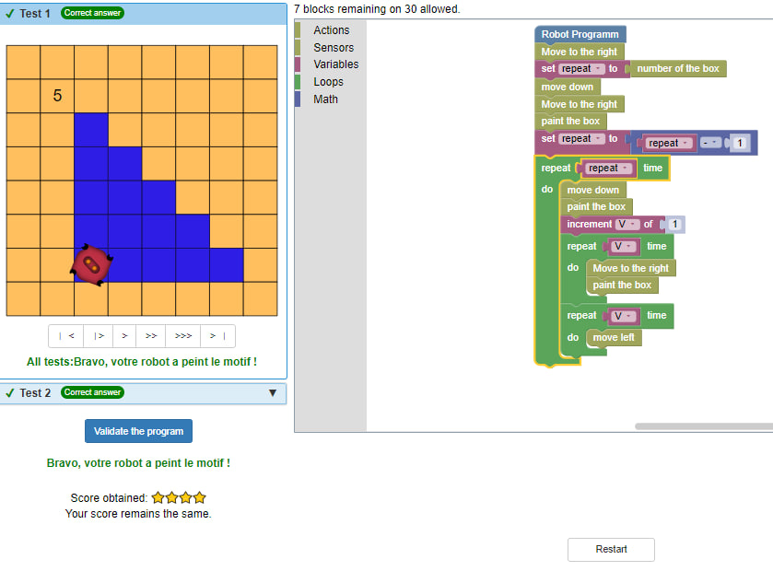](https://pnc-blocky.netlify.app/exercices/2019/e-jf/pnc-variable-3-paint-number/index.html)

[6- Sokoban (2)](https://pnc-blocky.netlify.app/exercices/2019/e-jf/pnc-variable-6-sokoban/index.html)

1. [Version1](https://pnc-blocky.netlify.app/exercices/2019/e-jf/pnc-variable-3-paint-number/index.html)

[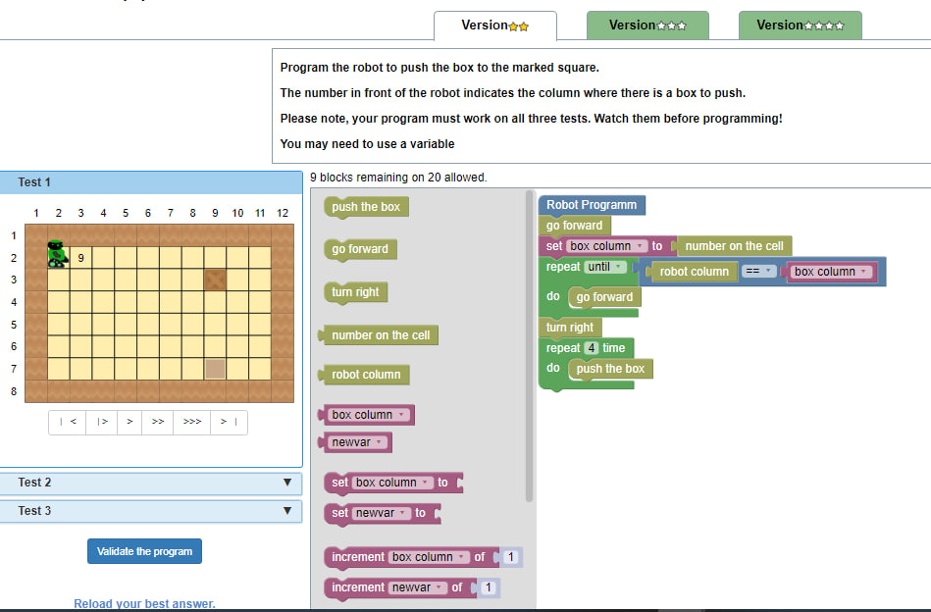](https://pnc-blocky.netlify.app/exercices/2019/e-jf/pnc-variable-3-paint-number/index.html)

1. [Version2](https://pnc-blocky.netlify.app/exercices/2019/e-jf/pnc-variable-3-paint-number/index.html)

[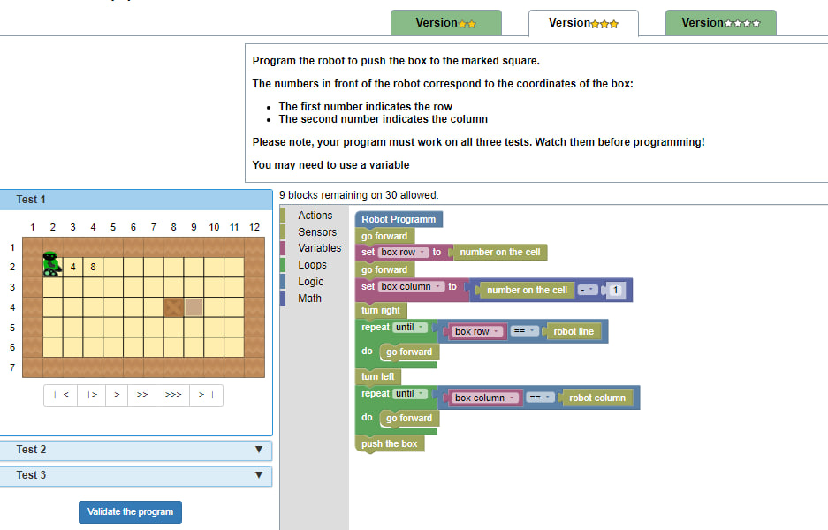](https://pnc-blocky.netlify.app/exercices/2019/e-jf/pnc-variable-3-paint-number/index.html)

1. [Version3](https://pnc-blocky.netlify.app/exercices/2019/e-jf/pnc-variable-3-paint-number/index.html)

[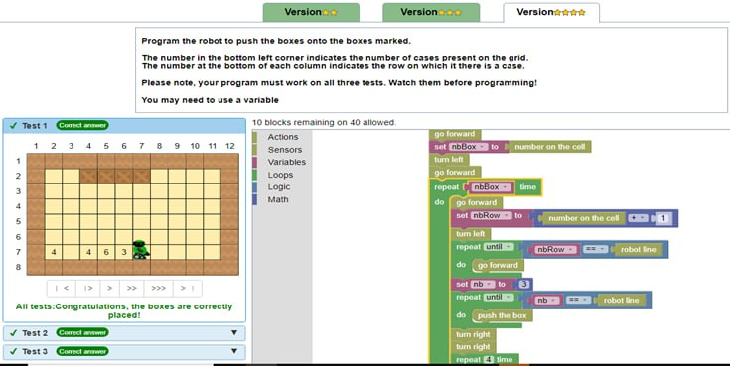](https://pnc-blocky.netlify.app/exercices/2019/e-jf/pnc-variable-3-paint-number/index.html)

[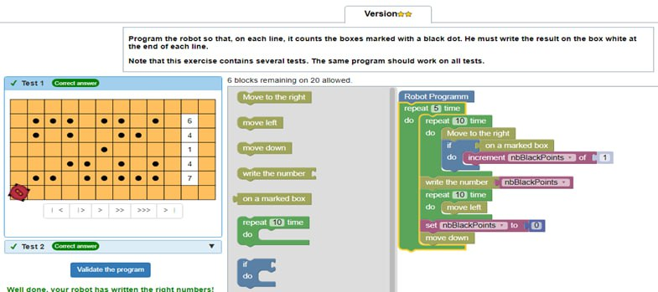7- Compute the sum](https://pnc-blocky.netlify.app/exercices/2019/e-jf/pnc-variable-7-paint-number/index.html)

[8- Paint the dots (easy)](https://pnc-blocky.netlify.app/exercices/2019/e-jf/pnc-loop-paint-1/index.html)

1. [Version1](https://pnc-blocky.netlify.app/exercices/2019/e-jf/pnc-loop-paint-1/index.html)

[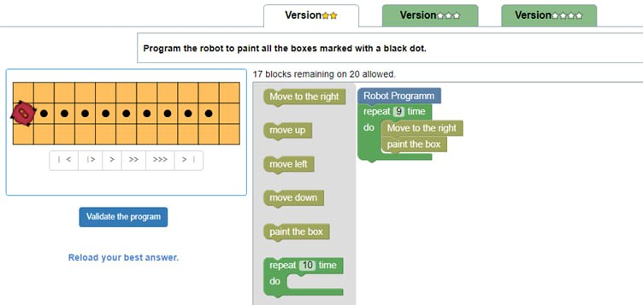](https://pnc-blocky.netlify.app/exercices/2019/e-jf/pnc-loop-paint-1/index.html)

1. [Version2](https://pnc-blocky.netlify.app/exercices/2019/e-jf/pnc-loop-paint-1/index.html)

[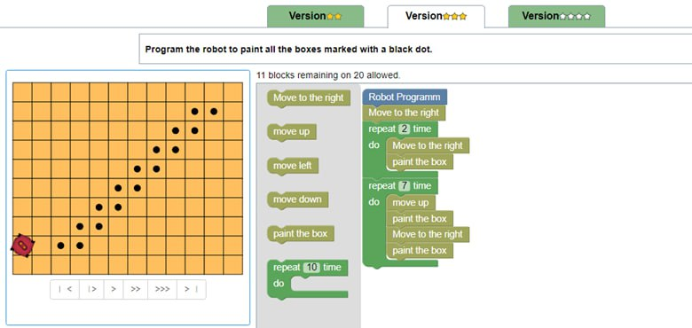](https://pnc-blocky.netlify.app/exercices/2019/e-jf/pnc-loop-paint-1/index.html)

1. [Version3](https://pnc-blocky.netlify.app/exercices/2019/e-jf/pnc-loop-paint-1/index.html)

[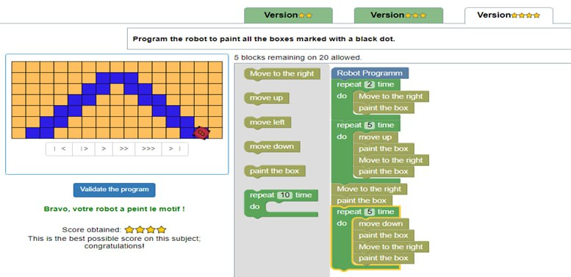](https://pnc-blocky.netlify.app/exercices/2019/e-jf/pnc-loop-paint-1/index.html)